

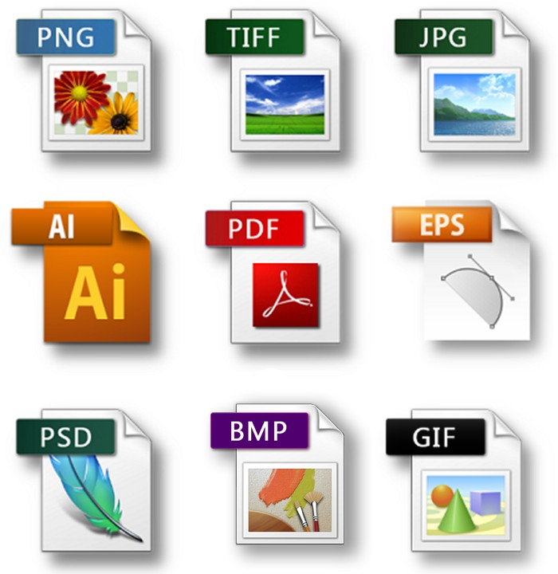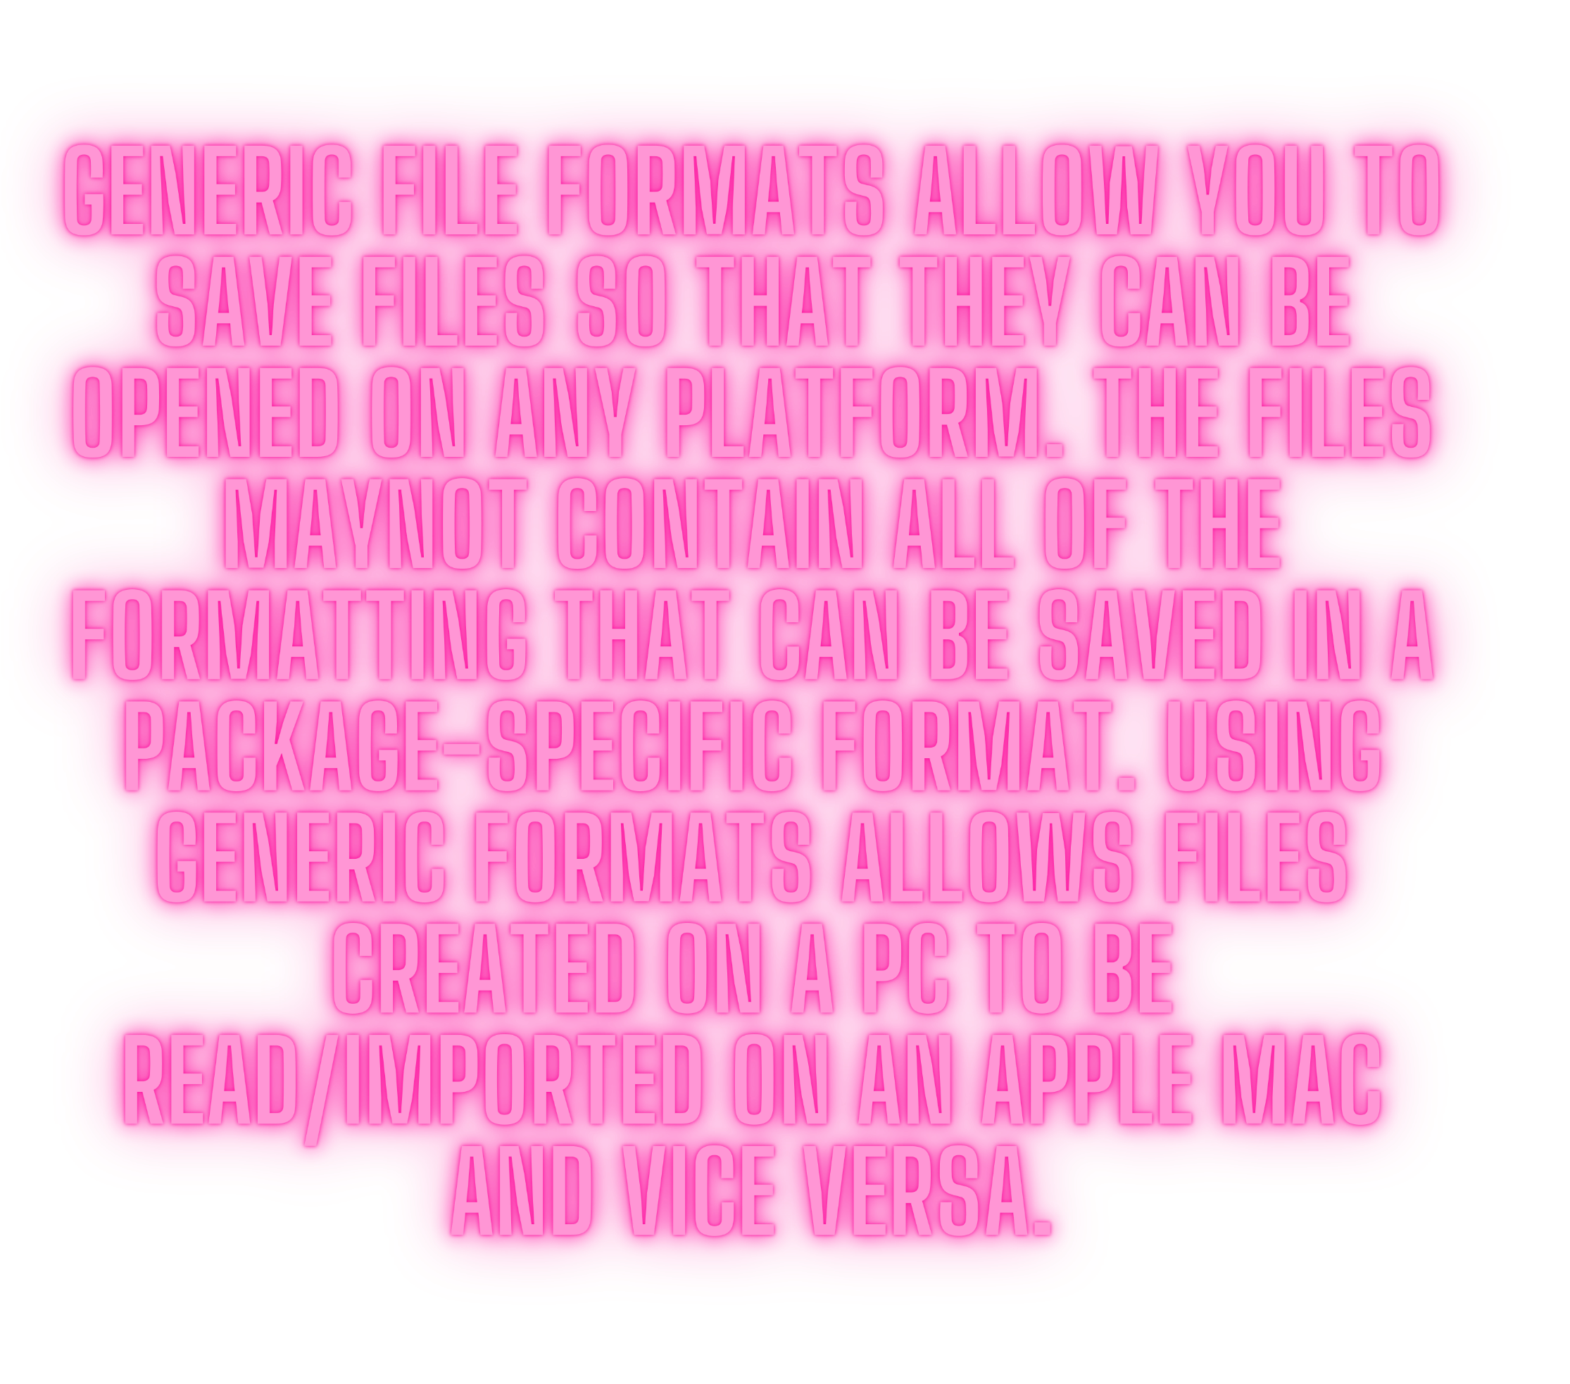

**I N A N U T S H E L L , G E N E R I C S E N A B L E T Y P E S *(* C L A S S E S A N D I N T E R F A C E S *)* T O B E**

**P A R A M E T E R S W H E N**

**D E F I N I N G C L A S S E S , I N T E R F A C E S A N D**

**M E T H O D S .**

COMMON GENERIC TEXT FILES INCLUDE:

COMMA SEPARATED VALUES:.CSV FILE EXTENSION,THIS FILE TYPE TAKES DATA IN THE FORM OF TABLES AND SAVES IT IN TEXT FORMAT, SEPARATING DATA ITEMS

WITHCOMMAS.

TEXT:.TXTFILE EXTENSION.A TEXT FILE IS NOT FORMATTED AND CAN BE OPENED IN ANY WORD PROCESSOR.

RICH TEXT FORMAT:RTFFILE EXTENSION.THIS IS A TEXT FILE TYPE THAT SAVES SOME OF THE FORMATTING WITHIN THE TEXT

COMMON GENERIC IMAGE FILES INCLUDE:

GRAPHIC INTERCHANGE FORMAT:GIF THIS FORMAT STORES STILL OR MOVING IMAGES AND IS AN EFFICIENT METHOD OF STORING IMAGES USING ASMALLER FILE SIZE, PARTICULARLY WHERE THERE ARE LARGE AREAS OF SOLID COLOUR.IT IS WIDELY USED IN WEBPAGES.

## JOINT PHOTOGRAPHIC EXPERT GROUP:JPG/JPEG , THIS FORMAT STORES STILL IMAGES ONLY.IT IS AN EFFICIENT METHOD OF STORING IMAGES USING A SMALLER FILESIZE AND IS WIDELY USED IN WEB PAGES.

PORTABLE DOCUMENT FORMAT:PDF , THIS IS A DOCUMENT THAT HAS BEEN CONVERTED INTO AN IMAGE FORMAT.THE PAGES CAN CONTAIN CLICKABLELINKS, VIDEO AND AUDIO.YOU CAN PROTECT A DOCUMENT IN PDF FORMAT TO STOP OTHERS FROM EDITING IT.

## PORTABLE NETWORK GRAPHICS:PNG , IT WAS CREATED TO REPLACE GIF AND IS NOW THE MOST USED LOSSLESS COMPRESSION FORMAT USED FOR IMAGESON THE INTERNET

COMMON GENERIC VIDEO FILES INCLUDE:

MOVING PICTURES EXPERT GROUP LAYER 4 : THESE FILES HAVE A .MP4 FILE EXTENSION . IT IS NOT A SINGLE FILE FORMAT BUT IT IS A MULTIMEDIA CONTAINER WHICH IS USED FOR

STORING VIDEO FILES,STILL IMAGES,AUDIO FILES, SUBTITLES E.T.C

COMMON GENERIC AUDIO FILES INCLUDE: MOVING PICTURES EXPERT GROUP LAYER 3:

THESE FILES HAVE A .MP3 FILE EXTENSION. IT IS A COMPRESSED FILE FORMAT USED FOR

LISTENING AUDIO FILES . THIS FORMAT CANNOT STORE STILL OR MOVING IMAGES

COMMON GENERIC FILES USED FOR WEB AUTHORING INCLUDE:

CASCADING STYLE SHEET : THESE FILES HAVE A .CSS FILE EXTENSION. THIS IS A STYLE SHEET SAVED IN CASCADING STYLE SHEET FORMAT AND IS ATTACHED TO ONE OR MORE WEB PAGES TO DEFINE THE PAGES COLOUR SHEME,FONTS,E.T.C

HYPERTEXT MARKUP LANGUAGE : THESE FILES HAVE A .HTM FILE EXTENSION. THIS IS A TEXT BASED LANGUAGE USED TO CREATE CONTENT THAT IS USED TO DISPLAY AS A WEB PAGE

COMMON GENERIC COMPRESSED FILES INCLUDE:

ROSHAL ARCHIVE : THESE FILES HAVE A .RAR FILE EXTENSION. THIS IS A CONTINER WHICH CAN HOLD ANY FILE TYPE IN

# COMPRESSEDFORMAT. IT IS USED TO REDUCE NUMBER OFBYTES NEEDED TO SAVE A FILE EIETHER TO SAVE STORAGE SPACE OR NUMBER OF BYTES

ZIP: THESE FILES HAVE A .ZIP FILE EXTENSION. THIS IS A CONTINER WHICH CAN HOLD ANY FILE TYPE IN

# COMPRESSEDFORMAT. IT IS USED TO REDUCE NUMBER OFBYTES NEEDED TO SAVE A FILE EIETHER TO SAVE STORAGE SPACE OR NUMBER OF BYTES

